Appendix

Data Description

Building Quality (BQ variables)
- MBMANCLS: Indicates the main building class
- MBYRBLT: The year the main building was constructed.
- MBEFFYR: The effective year built, considering renovations and depreciation.
- LINMCLS: A scaled version of the main building class
- MBMCLSDV: The percentage deviation from the main building quality class

Building Additive (BA variables)
- BEDROOMS: Number of bedrooms in the property.
- BATHS: Number of bathrooms.
- FAMILYRM: Count of family or recreation rooms.
- FIREPLCS: Number of fireplaces.
- FLRAREA1: Area of the first floor.
- FLRAREA2: Area of the second floor.
- BSMTFIN: Finished basement area.
- CRWLAREA: Crawl space area.
- BMSTAREA: Full-height basement area.
- UNFINBMT: Unfinished basement area.
- AREA1_2: Total area of the first and second floors.
- TOTAREA: Total finished area, including the basement.
- BASESTE: Binary – indicates if there is a basement suite.
- DECKAREACOVERED: Covered deck area.
- DECKAREAUNCOVERED: Uncovered deck area.
- HEATTYPE: The type of heating system, which can influence the property’s desirability and value.

Land Qualitative (LQ variables)
- CORNER: Indicates if the lot is a corner lot.
- WOODED: Indicates if the lot is more wooded than typical lots in the neighbourhood.
- PIE_SHPE: Indicates if the lot is pie-shaped.
- SLOPE: Indicates if the lot is sloped.
- ABV_ROAD: Indicates if the lot is above the road level.
- CULDESAC: Indicates if the lot fronts on a cul-de-sac.

Other Building Qualitative and Additive (OQ and OA variables)
- GARAGEFL: Indicates the presence of a garage.
- CARPTFL: Indicates the presence of a carport.
- CP_AREA: Total area of the carport.
- GAR_AREA: Total area of the garage.

Variable Transformation
Table A 1. Mapping between Manual Class and Scaled Numeric Value
Garage/Carport Manual Class (factors) | Scaled Numeric Value
910/911 | 0.450
920/921 | 1.000
930/931 | 1.200
940/941 | 1.420

Variable Examination
Fig A 1. Variable Correlation with Response Variable – Moderate Correlation
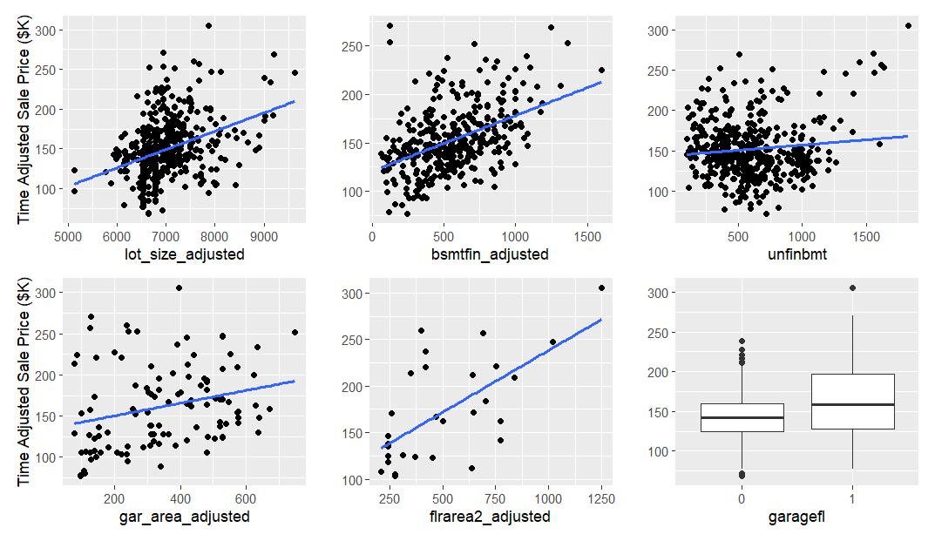
R²=0.01
R²=0.42
R²=0.14
R²=0.01
R²=0.21

Fig A 2. Variable Correlation with Response Variable – Moderate Correlation
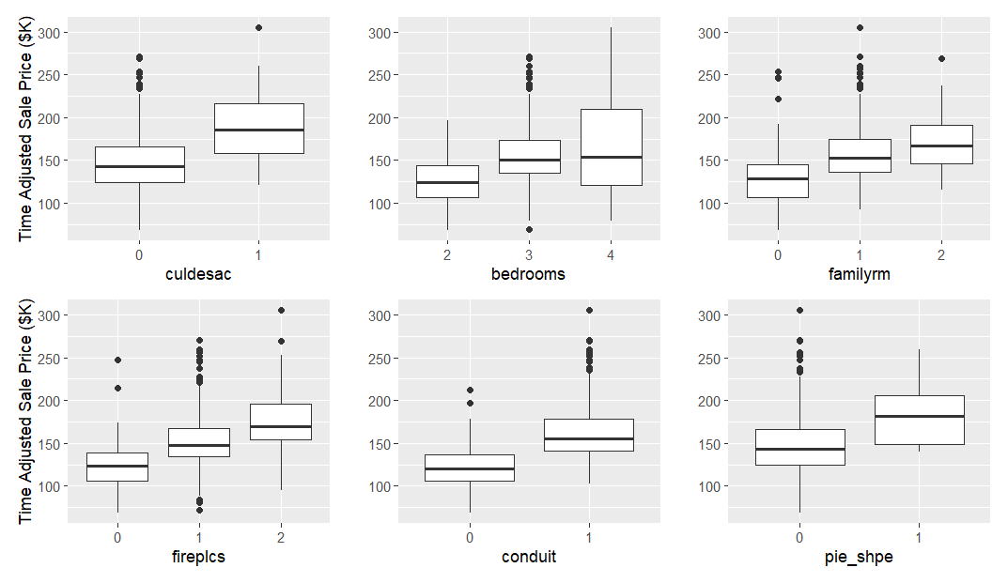
R²=0.33
Fig A 3 Variable Correlation with Response Variable – Low Correlation
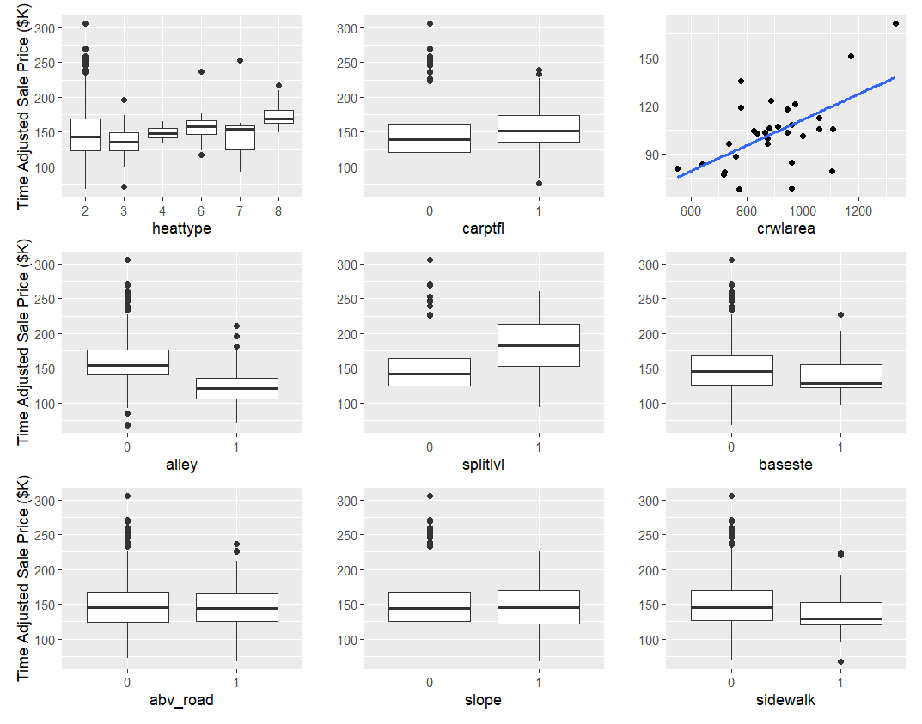

Fig A 4. Variable Correlation with Response Variable – Low Correlation
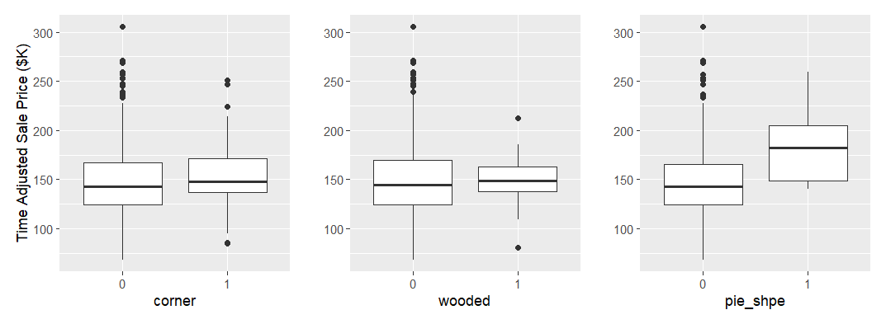

Step 7 – Model Calibration

Stepwise Regression
Table A 2 – Model Summary for the Models between Steps
Model | R | R Squared | Adjusted R Squared | Std. Error of the Estimate | F Statistic
Model1 | 0.897 | 0.805 | 0.797 | 16564.210 | 102.295
Model2 | 0.897 | 0.805 | 0.797 | 16545.990 | 108.550
Model3 | 0.897 | 0.804 | 0.797 | 16551.060 | 115.184
Model4 | 0.896 | 0.804 | 0.797 | 16557.110 | 122.684
Model5 | 0.896 | 0.802 | 0.796 | 16601.870 | 130.495

Table A 3 Model Variables for the Models between Steps
Model | Predictors:
Model1 | familyrm, flrarea2_adjusted, lot_size_adjusted, fireplcs, baseste, pie_shpe, heattype, effage, culdesac, splitlvl, sidewalk, garagefl, area1_2_adjusted, bsmtfin_adjusted, crwlarea, conduit, bedrooms, baths
Model2 | familyrm, flrarea2_adjusted, lot_size_adjusted, fireplcs, baseste, pie_shpe, effage, culdesac, splitlvl, sidewalk, garagefl, area1_2_adjusted, bsmtfin_adjusted, crwlarea, conduit, bedrooms, baths
Model3 | familyrm, lot_size_adjusted, fireplcs, baseste, pie_shpe, effage, culdesac, splitlvl, sidewalk, garagefl, area1_2_adjusted, bsmtfin_adjusted, crwlarea, conduit, bedrooms, baths
Model4 | familyrm, lot_size_adjusted, fireplcs, baseste, pie_shpe, effage, splitlvl, sidewalk, garagefl, area1_2_adjusted, bsmtfin_adjusted, crwlarea, conduit, bedrooms, baths
Model5 | familyrm, lot_size_adjusted, fireplcs, baseste, pie_shpe, effage, splitlvl, sidewalk, garagefl, area1_2_adjusted, bsmtfin_adjusted, crwlarea, conduit, baths

Step 8 – Model Testing

Model Adjustment
Table A 4. Ratio Statistics for ASR after Adjustment
Neigh | Median | Lower Bound | Upper Bound | Actual Coverage | Minimum | Maximum | COD
713 | 0.99 | 0.96 | 1.03 | 95.6 | 0.78 | 1.32 | 8.56
715 | 1 | 0.97 | 1.05 | 94.6 | 0.8 | 1.28 | 7.45
716 | 1 | 0.99 | 1.02 | 95.3 | 0.82 | 1.22 | 5.95
731 | 1 | 0.94 | 1.05 | 92.2 | 0.9 | 1.18 | 7.59
734 | 1 | 0.92 | 1.03 | 93.5 | 0.85 | 1.16 | 7.16
736 | 1.09 | 0.97 | 1.1 | 93.6 | 0.89 | 1.24 | 6.65
737 | 0.99 | 0.96 | 1.01 | 93.7 | 0.76 | 1.22 | 7.94

Table A 5. Ratio Statistics for ASR before Manual Class Adjustment
Manual Class | Median | Lower Bound | Upper Bound | Minimum | Maximum | COD
40 | 0.92 | 0.85 | 0.93 | 0.85 | 0.93 | 1.95
51 | 0.85 | 0.85 | 0.85 | 0.85 | 0.85 | 0
80 | 1.02 | 0.98 | 1.09 | 0.91 | 1.37 | 8.69
81 | 0.94 | 0.78 | 1.13 | 0.78 | 1.13 | 7.58
90 | 1 | 1 | 1.02 | 0.76 | 1.24 | 7.05
92 | 1.05 | 0.97 | 1.28 | 0.97 | 1.28 | 7.18
140 | 1 | 0.98 | 1.01 | 0.79 | 1.22 | 6.73
142 | 0.91 | 0.86 | 0.97 | 0.86 | 0.97 | 4.44
145 | 0.93 | 0.82 | 1.03 | 0.82 | 1.03 | 6.08

Table A 6. Ratio Statistics for ASR after Manual Class Adjustment
Manual Class | Median | Lower Bound | Upper Bound | Minimum | Maximum | COD
40 | 1.01 | 0.92 | 1.01 | 0.92 | 1.01 | 1.95
51 | 1 | 1 | 1 | 1 | 1 | 0
80 | 0.98 | 0.94 | 1.05 | 0.87 | 1.32 | 8.69
81 | 0.94 | 0.78 | 1.13 | 0.78 | 1.13 | 7.58
90 | 1 | 1 | 1.02 | 0.76 | 1.24 | 7.05
92 | 1.05 | 0.97 | 1.28 | 0.97 | 1.28 | 7.18
140 | 1 | 0.98 | 1.01 | 0.79 | 1.22 | 6.73
142 | 1 | 0.95 | 1.07 | 0.95 | 1.07 | 4.44
145 | 0.93 | 0.82 | 1.03 | 0.82 | 1.03 | 6.08

Table A 7. No Adjustment for heattype, bedroom, culdesac, and conduit
 | heattype | bedroom | culdesac | alley | conduit
Kruskal-Wallis H | 4.52 | 5.58 | 0.14 | 0.19 | 0.60
df | 5 | 2 | 1 | 1 | 1
Asymp Sig. | 0.48 | 0.07 | 0.71 | 0.66 | 0.43

Table A 8. Ratio Statistics for ASR before sidewalk Adjustment
Side Walk | Median | Lower Bound | Upper Bound | Minimum | Maximum | COD
0 | 1 | 0.99 | 1.01 | 0.72 | 1.4 | 7.41
1 | 1.06 | 1 | 1.1 | 0.85 | 1.34 | 8.02

Table A 9. Ratio Statistics for ASR after sidewalk Adjustment
Side Walk | Median | Lower Bound | Upper Bound | Minimum | Maximum | COD
0 | 1 | 0.99 | 1.01 | 0.72 | 1.4 | 7.41
1 | 1 | 0.95 | 1.04 | 0.8 | 1.26 | 8.02

